**WORLD SUICIDE CASES (1985 – 2016)**

Suicide is the act of intentionally causing one's own death. Suicide is a permanent solution to a temporary problem. Prior to the late nineteenth century, suicide was legally defined as a criminal act in most Western countries. In the social climate of the early 2000s, however, suicidal behavior is most commonly regarded and responded to as a psychiatric emergency.

There are quite many factors that influence suicide; however, in this study, we look at the impact of Gross Domestic Product (GDP) of a country, on its suicide rate, while also considering studying the suicide rate across the different age ranges, sorted as generations. This is based on the year of birth of the victim, and a general overview of the classification.

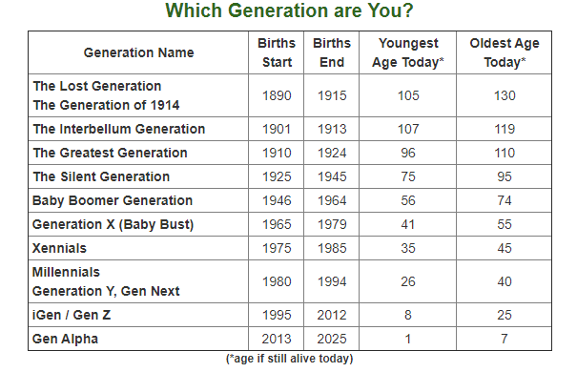

Source: <https://www.careerplanner.com/Career-Articles/Generations.cfm>

N.B: the ages contained herein are estimated using the year 2020 as the current year.

The data set used for this study captured the reported cases of suicide across 101 countries and spans between 1985 - 2016 (32 years). It was obtained from Kaggle via <https://www.kaggle.com/russellyates88/suicide-rates-overview-1985-to-2016>.

Upon obtaining the data, an additional feature (Continent) was created to study the continental suicide rate further, considering the impacts of GDP ($ per-capital) and population.

This study made use of Microsoft Power BI as its analytics tool, and the results of the analysis are discussed as follows;

1. The continental breakdown for the number of countries captured in the data set is discussed below;
   1. Europe: 41
   2. Asia: 21
   3. North America: 21
   4. South America: 10
   5. Africa: 4
   6. Oceania: 4
2. The total number of reported suicide cases over the period captured in this study is 7 million, and the continental breakdown is as follows;
   1. Asia: 3M
   2. Europe: 2M
   3. North America: 1M
   4. South America: 447K
   5. Oceania: 85K
   6. Africa: 11K
3. The average continental suicide rate/100k population breakdown is as follows;
   1. Asia: 19.62%
   2. Europe: 14.27%
   3. Oceania: 12.97%
   4. North America: 10.52%
   5. South America: 5.58%
   6. Africa: 1.25%
4. The Average continental GDP Per Capital ($) is as follows;
   1. Europe: $23.1K
   2. Oceania: $20.77K
   3. Asia: $16.64K
   4. North America: $11.25K
   5. Africa: $6.82K
   6. South America: $6.01K
5. The breakdown of suicide rate by gender and generation is as follows;

|  |  |  |  |  |  |  |
| --- | --- | --- | --- | --- | --- | --- |
| Generation/Sex | G.I Generation | Silent | Boomers | Generation X | Millennials | Generation Z |
| Male | 39.11% | 31.60% | 27.78% | 18.03% | 9.03% | 0.76% |
| Female | 13.87% | 9.30% | 6.79% | 4.63% | 2.56% | 0.50% |

1. The top 5 and bottom 5 countries by suicide rates are;
   1. Lithuania (41.18%), Russian Federation (32.78%), Sri Lanka (30.48%), Belarus (30.34%) and Hungary (29.72%)
   2. Dominica (0.00%), Saint Kitts and Nevis (0.00%), Oman (0.58%), Jamaica (0.81%) and Maldives (0.91%)
2. During the study, we observed that there is a negative correlation between Average GDP ($) and Suicide rate (/100k pop), i.e. suicide rate (/100k pop) decreases as average GDP ($) increases and vice versa. Similarly, there is a positive correlation between population and suicide rate, i.e. suicide rate (/100K pop) increases as population increases. It was also discovered that there is a positive correlation between population and average GDP ($), i.e. average GDP ($) increases as population increases.
3. The highest number of suicides occurred in the year 1999 (256119;14.42%)
4. The “key influencers” tool was used to investigate the rise/decline in suicide rate using Average GDP, Total Population and Age Range as explanatory variables, and Country and Generation as an expansion variable. Using this tool, it was discovered that when the age range is 5 -14, suicide rate (/100K pop) decreases by 21.64%, while as population decrease by 45673223, suicide rate (/100K pop) decreases by 1.85%. When the age range is 75+, the suicide rate increases by 21.06%, hence, it can be deduced that the two age ranges that influence suicide rate as 5 – 14 and 75+, with 75+ accounting for 21% increment in the suicide rate, and 5 -14 accounting for 22% decline in the suicide rate.